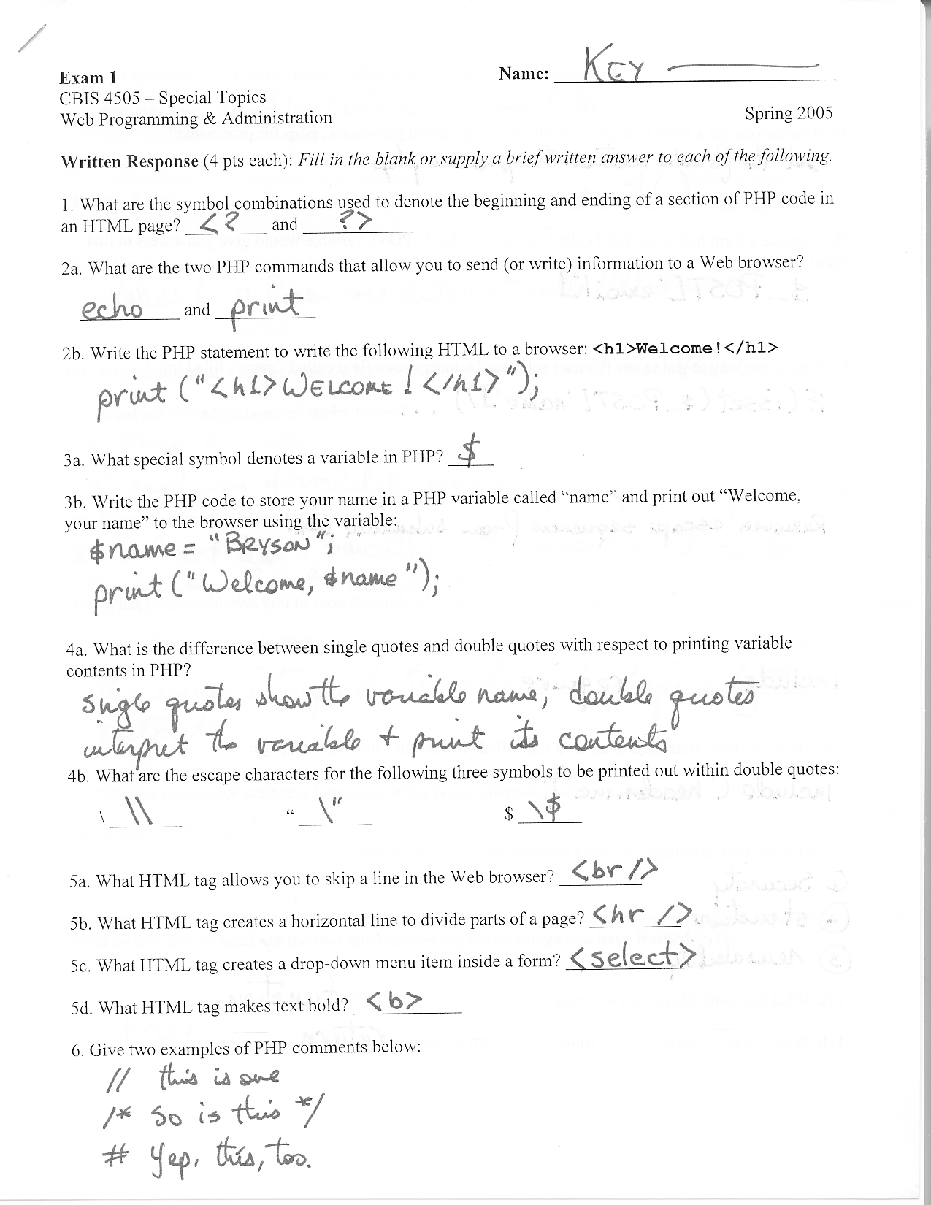
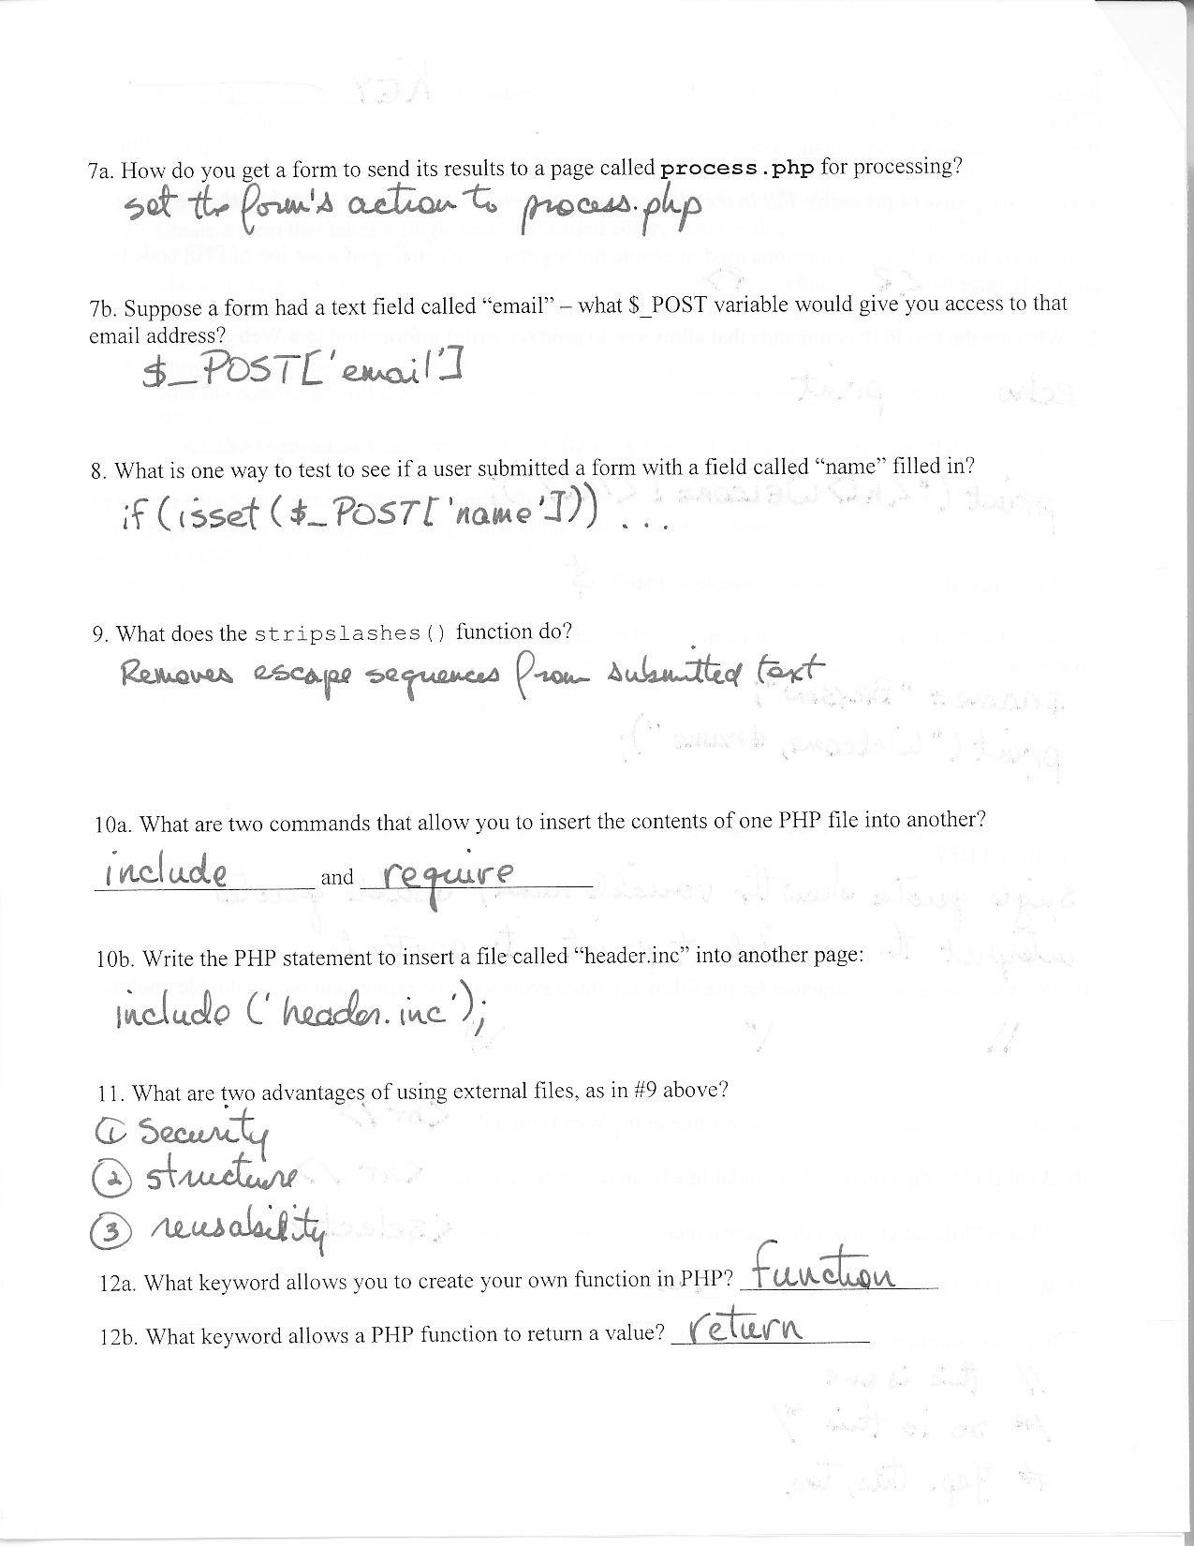

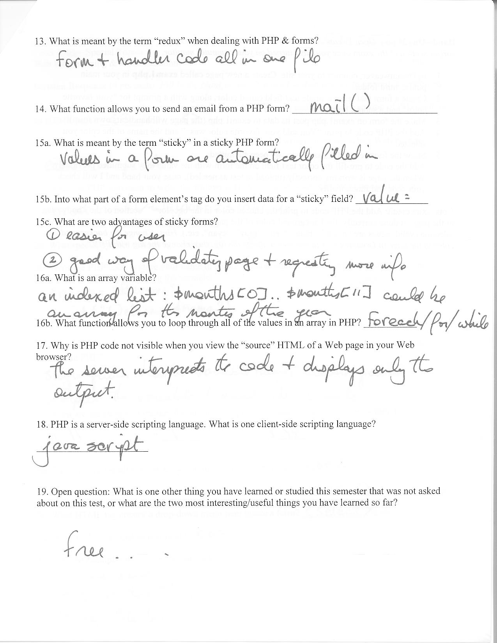
- Write the MySQL statement to query a table named “employees” for three fields (fname, lname, salary):

- What are the steps we follow for including MySQL data in a PHP page?

- Write the PHP code to form a query to make an INSERT statement to enter three values posted from a form (“fname”, “lname”, “ssn”) to a database table called “employees”:

